Candidate Pack

Assistant Director of Estates (Operations)

University of Hull

October 2014

The University of Hull is seeking to appoint an Assistant Director of Estates (Operations), based within the Estates Directorate on the Hull Campus, who will take up the post on 5th January 2015 (or as soon as possible thereafter). This candidate pack sets out the role description, person specification and the application protocol. It also provides background information regarding the University, the Estates Directorate, the City of Kingston Upon Hull and the East Riding of Yorkshire.

Contents

Message from the Vice-Chancellor 3
About the University of Hull 5
About the Estates Directorate 8
Role description and person specification 10
Application protocol 16
About Hull and the East Riding of Yorkshire 18

Message from the Vice-Chancellor

Vacancy for the Assistant Director of Estates (Operations)
I welcome your interest in the University of Hull and am delighted that you are considering applying for this post at what is an exciting time for the University.
The University of Hull is a prominent university in Yorkshire. It pursues its academic endeavours in the international arena, whilst at the same time recognising its responsibilities as an anchor institution in its local and regional communities.
The University of Hull articulated its vision and strategic intent in July 2011, and at the same published its Strategic Plan 2011-2015. The vision emphasises the pursuit of excellence, and our plans are bold and ambitious. A key objective is to enhance the University’s stature and reputation as it navigates the fast changing challenges of the higher education landscape. Our strategic plan builds on a proud heritage of academic achievements over more than eighty years, whilst clearly positioning the University of Hull as a forward-looking and engaged university, contributing proactively towards creating and shaping a better future through its passion for advancing knowledge, education and empowering people.
The articulation of our vision and the subsequent launch of the Strategic Plan initiated a period of significant renewal and transformation across the institution. Our task is now to pursue our chosen vision with determination and vigour, and to ensure that the vision guides our decisions and priorities.
The holder of this role will take responsibility for the strategic and operational management of the maintenance, grounds, cleaning, portering, security and energy teams to engender the ethos of customer service, efficiency and continuous improvement. They will contribute to the delivery of the Universities Strategic Plan and the Estates Master Plan through innovatively driving continuous improvement and efficiency in all areas while providing a flexible and responsive service.
Within this pack you will find the following:
- Background information on the University and the Estates Directorate
- Role description and person specification
- Background information on Hull and the East Riding of Yorkshire
- Application protocol
I very much look forward to receiving your application for what will be a stimulating, challenging and professionally fulfilling role.
Yours sincerely,
Professor Calie Pistorius
Vice-Chancellor

The Vice-Chancellor, Professor Calie Pistorius
Professor Calie Pistorius took up the position of Vice-Chancellor at the University of Hull on 1 September 2009. He was previously Vice-Chancellor and Principal of the University of Pretoria in South Africa from 2001 until 2009 and a former chairman of the National Advisory Council on Innovation (NACI) in South Africa.
Professor Pistorius obtained a BSc(Eng)(cum laude) in electronic engineering from the University of Pretoria in 1979 and a BEng (Hons) (cum laude) in electronic engineering from the same university in 1981. He obtained a Master of Science degree in electrical engineering from the Ohio State University in 1984, a PhD in electrical engineering from the same university in 1986, and a Masters degree in the management of technology from the Massachusetts Institute of Technology in 1994. He is also an alumnus of the Harvard Business School, having completed the AMP programme in October 2003.
Professor Pistorius is a Chartered Engineer, a Fellow of the IET, the Royal Society of South Africa and South African Academy of Engineering, a Member of the Academy of Science of South Africa and a Senior Member of the IEEE. He is a member of boards of the Humber Local Economic Partnership (LEP), Yorkshire Universities and The Deep, and serves on the regional board of the CBI for Yorkshire and the Humber. He has acted as a consultant on issues relating to national innovation policy, competitiveness, management of technology and innovation, and published widely in these fields.

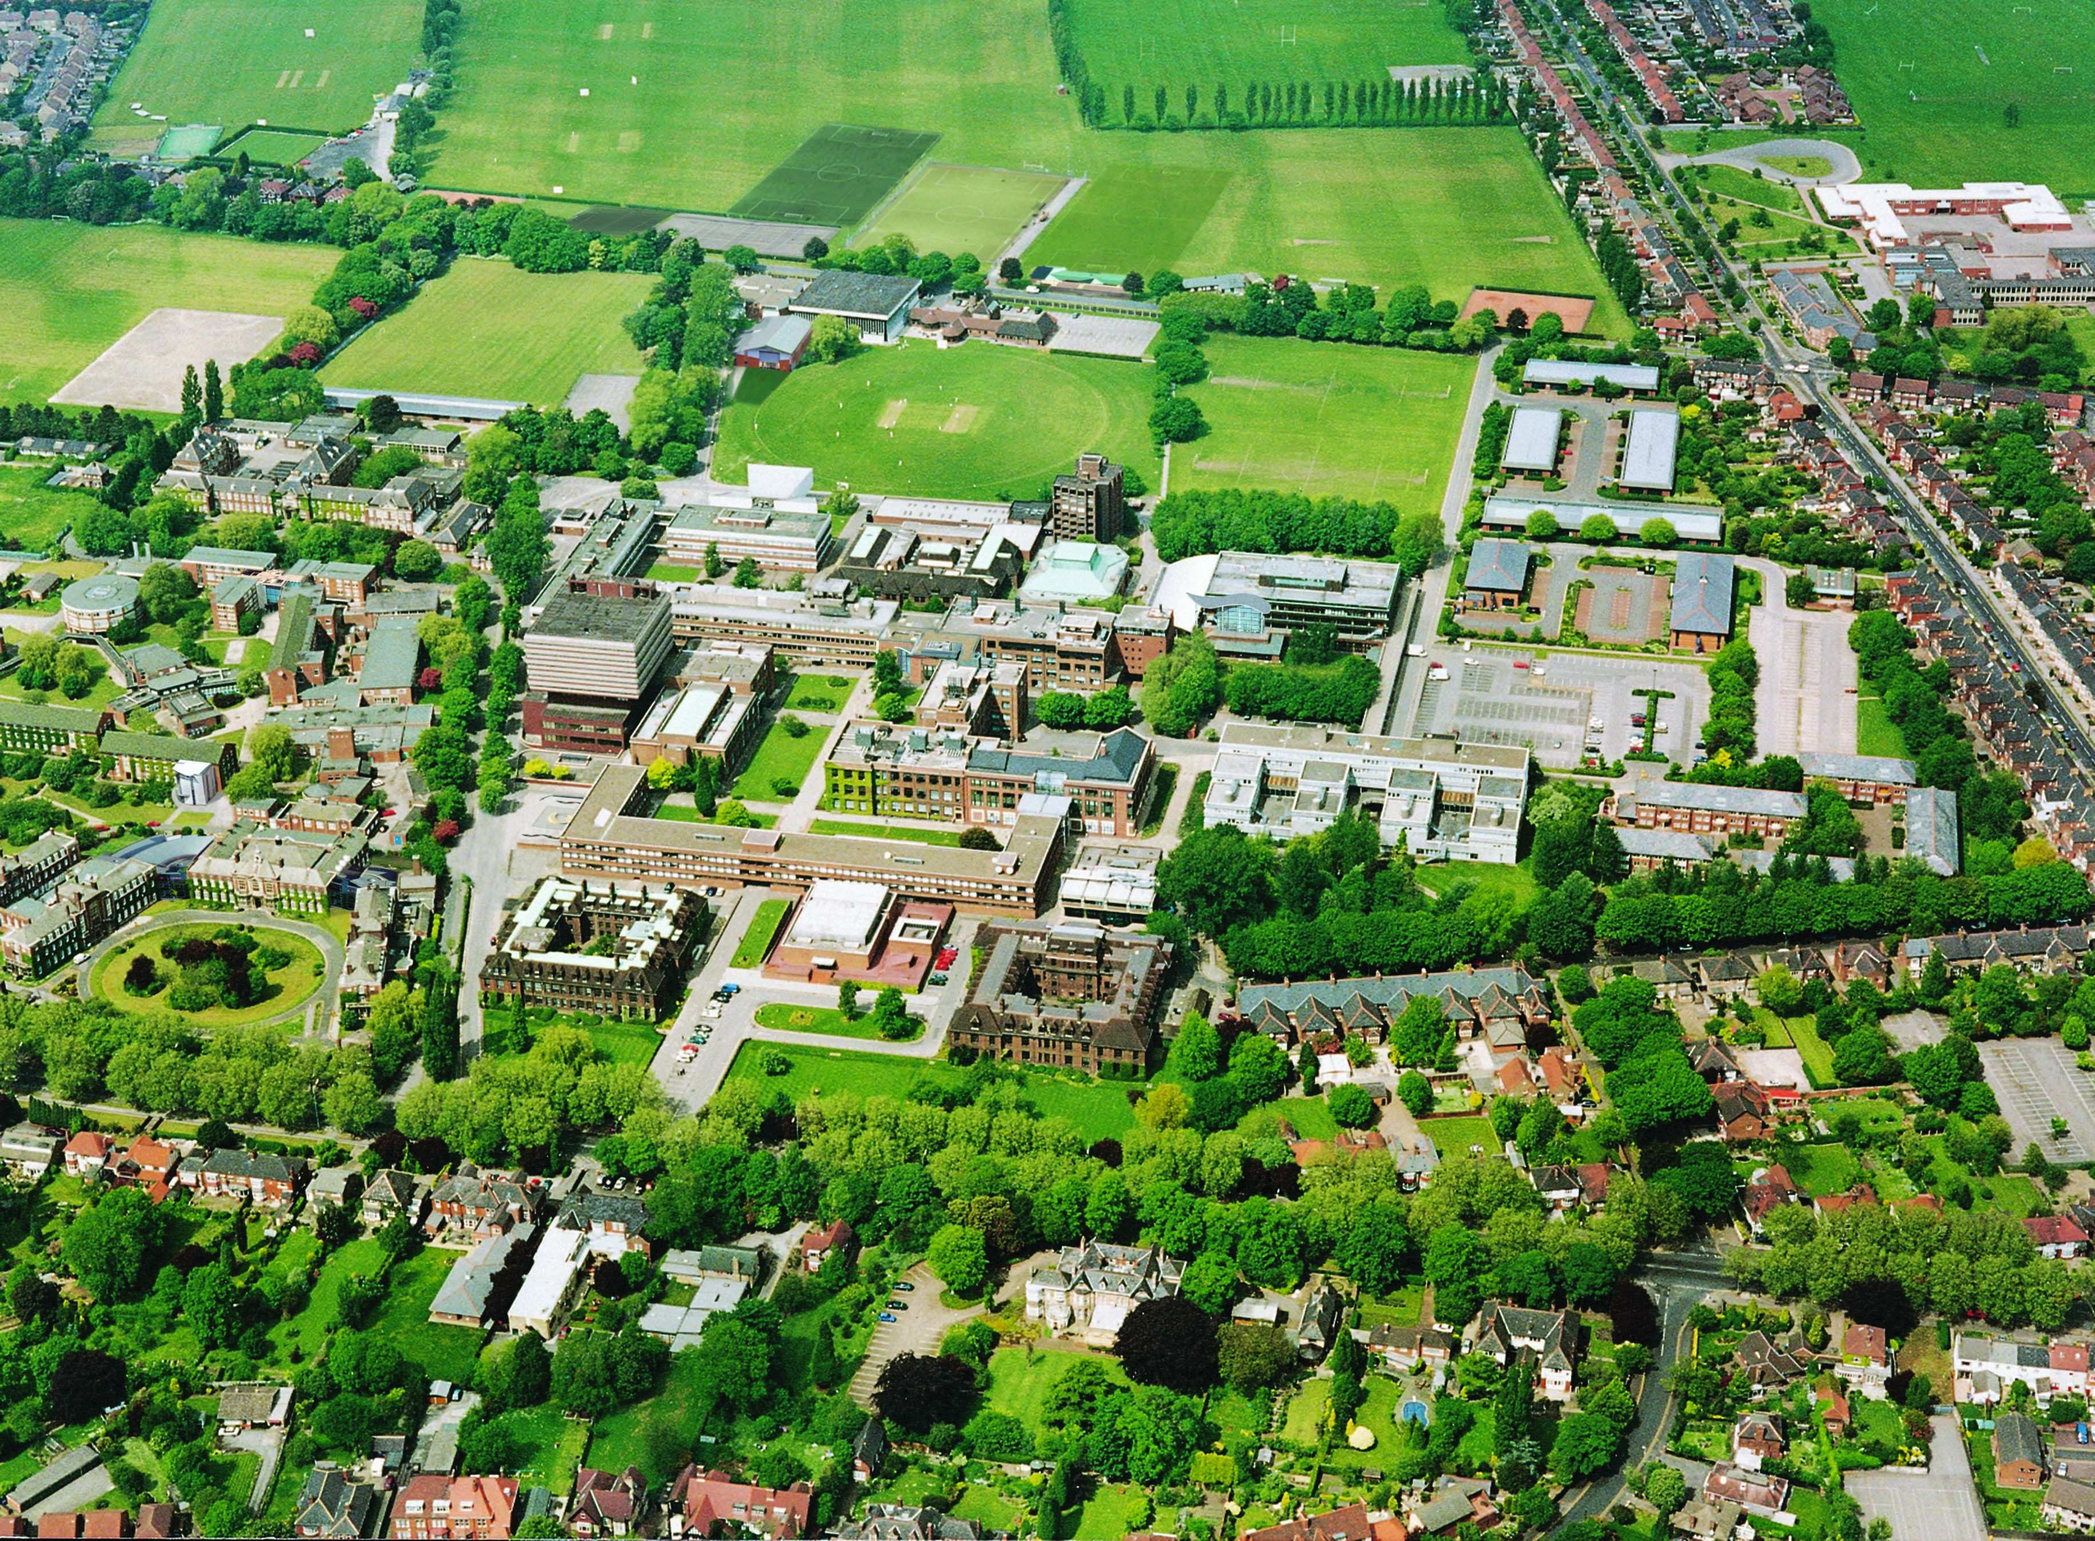
About the University of Hull
Hull campus
The University of Hull is an institution with a long heritage of academic excellence and is rich in tradition. Established in 1927 as University College Hull, it was initially an outpost of the University of London. In 1954 it was granted a Royal Charter and became England’s fourteenth university. The University’s alumni and staff include some of the most inspirational figures of modern times. It has an illustrious history which includes pioneering developments in science and engineering, health, business, education, humanities and social sciences as well as performing arts. The University today is a vibrant and future-oriented institution, recognised for excellence in learning and teaching as well for its commitment to research, enterprise and engagement. The University is known for its friendliness, high quality student experience and outstanding student satisfaction, as well as the employability of its graduates.
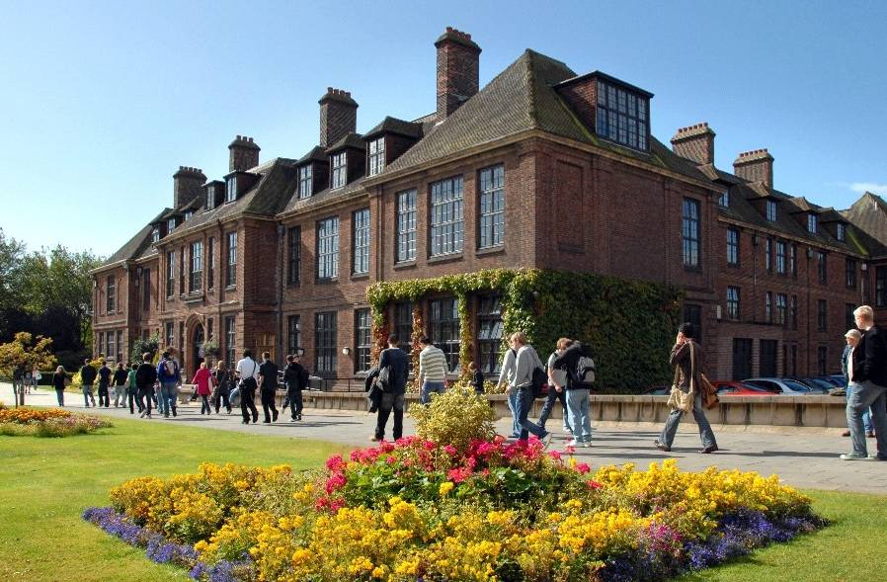
Venn Building

The University’s main campus is located in Kingston upon Hull on the north bank of the River Humber, with a satellite campus in Scarborough in North Yorkshire. It is one of only a handful of coastal universities on the east coast of England, and is the primary provider of higher education in its hinterland in Hull and the Humber region, the East Riding of Yorkshire, North Yorkshire, North Lincolnshire and North East Lincolnshire. Circa 18,000 students are enrolled at the University, including more than 2,000 international students.
The University’s academic structure is arranged in six faculties, viz. the Faculty of Arts and Social Sciences, Faculty of Education, Faculty of Health and Social Care, Faculty of Science and Engineering, Hull University Business School and the Hull York Medical School (jointly with the University of York).
Research and enterprise are core academic activities of the University. Amongst its most well-known achievements are the discovery of liquid crystals that made liquid crystal displays possible and the bone density scanner which revolutionised the detection of osteoporosis. Both of these were featured in Eureka UK's list of ‘100 discoveries and developments in UK universities that have changed the world’.
Hull University Business School
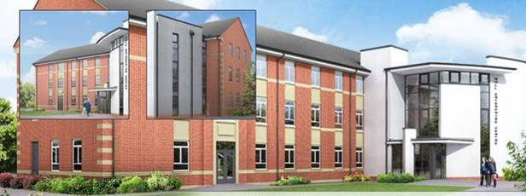
Enterprise Centre

The Strategic Plan (2011 – 2015)
In 2011 the University of Hull articulated its vision: to offer excellent learning and teaching, research intensity and innovative enterprise, an outstanding student experience, internationalization and an anchor institution role within a broader context of engagement.
“…advance education, scholarship, knowledge and understanding by teaching and research, for the benefit of individuals and society at large”
Royal Charter, University of Hull, 1954
At the same time it adopted an investment driven Strategic Plan (2011-2015) centred on the pursuit of excellence and securing a growth in stature and reputation. The University’s strategic objectives and the targets for each of its associated Key Performance Indicators are extremely ambitious; step changes, rather than merely incremental improvements, will be required if they are to be achieved.
These step changes will be manifested in a number of initiatives, including the introduction/enhancement of academic disciplines, the augmentation of the University’s existing interdisciplinary themes, opportunities posed by a multi-campus strategy. Four defined ‘change programmes’ are also underway, viz:
- The Student Experience Programme which keeps students at the heart of the University by ensuring they are offered a personalised experience in a supportive and creative environment;
- Curriculum 2016 which will refine and define the University’s core offering so that its students benefit from modern, attractive and stimulating courses;
- The Academic Investment Initiative which will shape the profile of the University’s academic staff for 2020 and support them to develop their research and teaching in new and exciting ways;
- The IT Transformation Journey which will enhance and enable academic and non-academic life across the University by improving information systems and services and introducing innovative solutions.
In the evolving higher education landscape securing such step changes is essential if the University is to enhance its standing in the sector and remain responsive and sustainable.

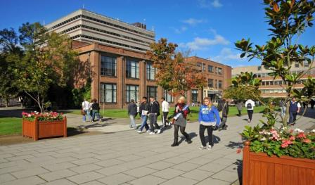

The challenge is great; but the University of Hull is a place where everyone contributes and is inspired by an ethos of ‘going beyond’. Only by doing things exceptionally well can the University achieve its vision. It is determined to exceed expectations and to encourage its students to strive for excellence in whatever they do in life.
The University is seeking people who share these ambitions and its passion for building a better world.
Detailed information regarding the University of Hull can be found on its website at: www.hull.ac.uk
Information regarding the University’s vision, mission and strategic plan can be found at: www.hull.ac.uk/strategy
Key documents, including the annual reports and statements of accounts are located at http://www2.hull.ac.uk/theuniversity/key-documents.aspx
An overview of the four change programmes can be found at www.hull.ac.uk/inspiring-change

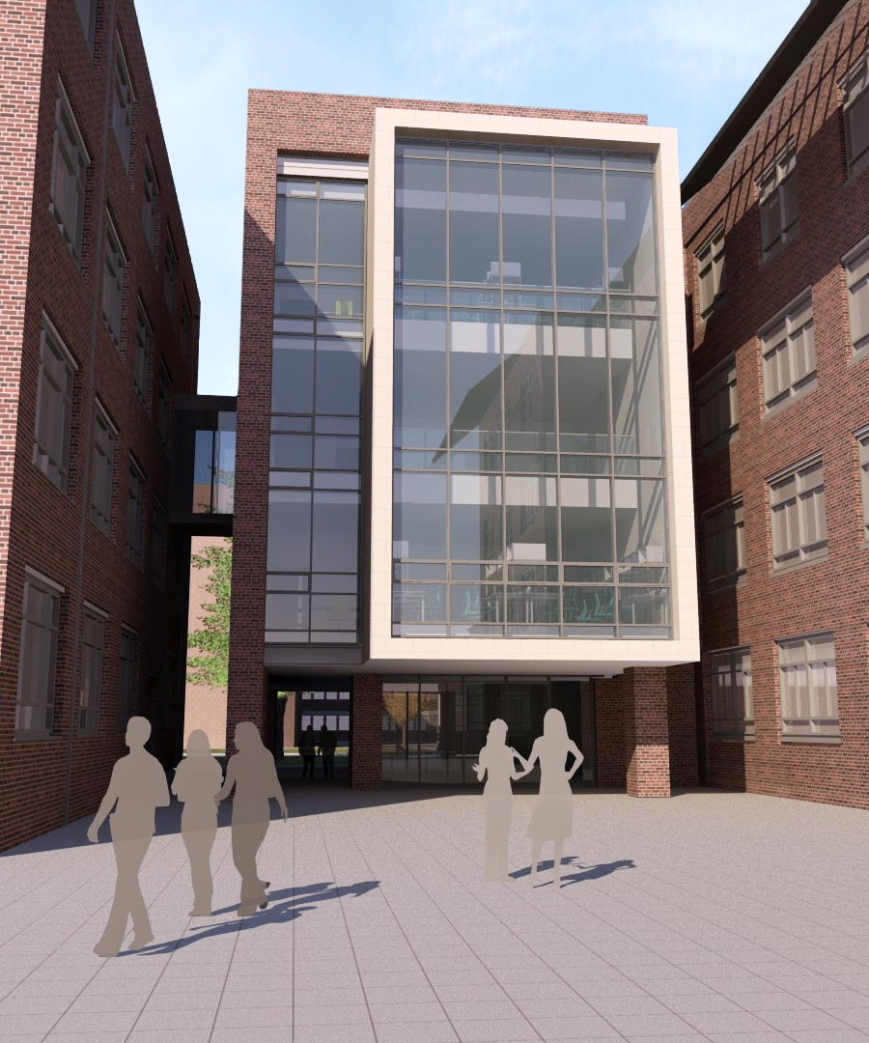
Allam Building
Brynmor Jones Library
About the Estates Directorate
The Estates Directorate is responsible for providing efficient maintenance, security, portering, and cleaning services across the whole University along with strategic planning and development to include an extensive Capital development programme.
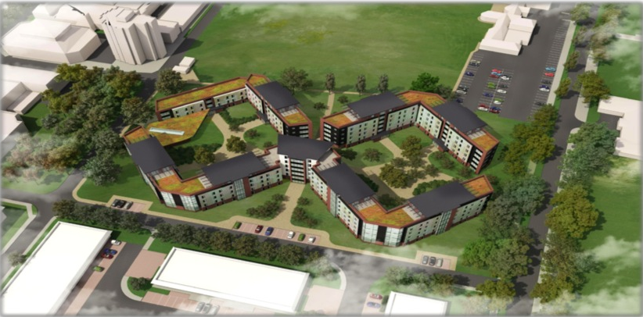
The University itself benefits from having what is primarily a single Campus University site in an attractive setting and we are committed to enhance this environment and develop it further to provide a true campus living experience for our students.
New Residences
The campus master plan is currently being developed to maximise opportunity from the wider site and capital program and integrate a site wide carbon management strategy, development of an excellent urban landscape environment to allow our students and staff to enjoy the environment and provide clear and natural wayfinding and circulation, along with sustainable travel provision and convenient parking.
The current Capital programme for delivery for the 2016/17 academic year extends to:
- £30m investment in circa 600 en-suite residences on campus.

- £24m investment into a new Health Campus to support the development of the Hull York Medical School and Faculty of Health and Social Care collaborative research activities.

- £8.5m refurbishment into a new state of the art performance and music recording facility.
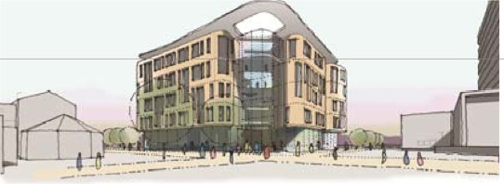
Further projects in the planning phase relate to the delivery of the new sports and fitness facility and a further phase of on site residential provision. We are also planning an innovative engineering building to support the university’s academic initiative to deliver skills for the sustainable technology businesses who are currently heavily investing in the Hull region.
Health Hub Building
The Operational side of the directorate is changing too with a new computer aided facilities management software package (Planon) being implemented at present. This will allow us to manage our Estates data in the best possible way and also deliver maintenance jobs direct to mobile devices. We will also be able to engage with BIM data from our Capital projects and use this to improve the information available to our maintenance staff.
We are seeking to improve our communication and make the Directorate as accessible as possible for our customers and provide the best possible communication channels. This will involve utilising our excellent in house teams in more innovative ways and making the most of the skills of all our staff at every level.
We will look to our new Assistant Directors to be enthusiastic, team oriented, imaginative and aspirational in their outlook as well as being organised and systematic in their approach to help us deliver an exciting future.

Role and person specification

Assistant Director of Estates (Operations)

Background and Context
The Estates Directorate offers a range of services including Estates management and development, Maintenance, Cleaning, Portering and Security. The directorate is responsible for a range of over 71 University buildings both academic and residential totalling over 150,000 square metres on the Hull Campus with an annual operational turnover of £8.6m.

The Assistant Director of Estates (Operations) will be responsible for the Strategic and operational management of the maintenance, grounds, cleaning, portering, security and energy teams to engender the ethos of customer service, efficiency and continuous improvement. The teams include:

- Maintenance and grounds teams led by the Head of Maintenance Operations supported by a team of 5 supervisors and 50 direct staff.
- Cleaning Services led by the Cleaning Services Manager providing the cleaning service for all academic buildings on the Cottingham Road Campus and for the cleaning of the student accommodation on and off the campus.
The cleaning team consists of over 100 part time staff, 12 supervising staff and 2 full time senior supervisors.
- Security, portering and post teams led by the Portering & Security Services Manager supported by 6 Shift Leaders / Supervisors, 24 direct staff and 8 contracted staff.
- An Energy and BMS Manager.

The role holder will contribute to the delivery of the Universities Strategic Plan through innovatively driving continuous improvement and efficiency in all areas while providing a flexible and responsive service.

Specific Duties and Responsibilities of the post
Manage and motivate the Estates Operational Team to deliver the highest service standards that enhance the student and staff experience and support the University’s strategic plan.

Ensure that all areas of operation are being carried out in a safe manner with due
attention being paid to health and safety requirements from a legislative, regulatory and
corporate perspective as well as following industry good practice.

Contribute to the continual development of customer focused services, promoting the
Estates Directorate by establishing and maintaining working relationships
throughout the University and by providing high quality, responsive and efficient services, setting a personal example of courtesy and high professional standards.

Play a significant role in maintaining and enhancing the value of the University’s environment, addressing energy, water, waste and carbon emission issues.

Ensure efficient processes and systems are in place to make the maximum use of Estates resource.

Supporting the Director as part of the senior Estates team, providing strategic advice and information on estates’ matters. Act on behalf of the Director as necessary in committees or steering groups or in other forum.

Main Work Activities

Overall

The role holder:

- Will be a professional specialist with high-level expertise and will have a considerable degree of independent professional responsibility and discretion, working to broad parameters and policy guidance.
- Will have responsibility for adapting or changing the service to ensure the appropriateness of, and the quality of the work and contribute to setting overall standards for the service across a function or area of the institution.
- Will influence decisions and developments within the University and contribute to setting overall standards across the University, Faculty or Department.
- Has responsibility for the operational planning and organisation of projects, an area of work, and/or teams. Sets performance standards and establishes monitoring procedures to keep track of progress and provide input to longer term planning.
- Applies creativity to devise varied solutions to problems where there is a mass of information or diverse, partial and conflicting data.

Communication
- Advise the Senior Management Group and other Senior University managers on the activity of a range of student/department/faculty issues in order to inform the development and implementation of future strategy.
- Advise Academic and Administrative senior management on specialist issues
- Monitor and report, as appropriate, on the delivery of core business against agreed targets to:
  - Identify where remedial action is required where performance does not meet agreed targets.
  - Review plans to take account of the need to adapt to changing circumstances.

Teamwork
- To be responsible for the operational objectives and day to day management of the Estates operational team in collaboration with the service Managers.
- To lead and manage the staff within the Estates Operational team including the effective, management of performance, conduct, capabilities, staff training and development.
- To continuously review processes in conjunction with the Estates Business Manager and staffing levels to optimise financial and operating performance and provide a smooth and seamless delivery across all areas.
- To support and assist the Assistant Director of Estates (Development) with regard to project implementation and the development of the estate as appropriate.
- Develop, implement and monitor staff training and development.

Liaison and Networking
- Ensure the development of effective ongoing relationships with University staff to align existing activity with the strategic direction of the department/faculty.
- Develop, manage and maintain productive strategic relationships and networks with senior representatives in a broad range of private and public sector partners to assist the continuing development, reputation and effectiveness of the University.
- Maintain close and proactive liaison with key stakeholders and focus groups to ensure customer delivery in line with Service Level Agreements.
- To liaise with key staff and emergency services with regard to the reporting of incidents and necessary follow-up action and to be a keyholder and contact for emergency call outside of normal working hours as necessary.
- To be involved with any emergency planning and implementation (especially during adverse weather conditions).
- The Assistant Director of Estates Operations will be expected to develop and maintain effective working relationships with:
    - Assistant Director Estates Development
    - Heads of Departments/Schools and Service Departments
    - Colleagues within Estates
    - Internal and external stakeholders

- Represent the University at a senior level at regional and national meetings, conferences and events relating to this area of activity.
- Be an active member of emerging networks.

Service Delivery
- Responsible for the overall service of the area which includes:
  - Setting standards to meet customer expectations.
  - Monitor standards and levels of service.
  - Obtain feedback and use research to inform developments and ensure quality.
  - Take appropriate action on the impact of external factors.
- To ensure security and portering staff, systems and equipment are effective, appropriate to meet the needs of the University and deliver a high level of customer service.
- To ensure an effective cleaning service is in place across the University Estate to established best practice that is efficient, flexible, highly customer focussed and meets the University’s needs.
- To put in place systems to efficiently utilise resource, monitor compliance and reduce reactive maintenance with a planned approach.

Planning and Organisation
- Devise and oversee delivery of planned long term maintenance programme.
- Ensure maintenance service contracts are appropriately prioritised against available resource and that they are procured to deliver value for money
- To manage and maintain the University’s external works and public realm through the Grounds and Gardening Team.
- Contribute to the development of information systems to support and compliment operations and maintenance activities.
- Ensure that maintenance and other operational activities comply with Health and Safety legislation and University policies. To include but not limited to Legionella and asbestos management.
- Lead the development, implementation and delivery of the University’s strategy.
- Plan, co-ordinate and be responsible for the delivery of projects and to play a key role in future strategic development for the continued development of the area.
- Develop and implement policies and procedures working closely with the Estates Business Manager.

Analysis/Reporting
- Manage and control delegated budgets in line with annually refreshed business plan.
- To ensure maintenance works are actively managed, records are kept and these are fed into central property records.
- Provide management reports in conjunction with the Director of Estates for University meetings and approval bodies.
- Responsible for the management of KPI’s in relation to performance of the teams.
- Ensure robust management, monitoring and financial systems are in place.
- Analyse data to provide timely and accurate information, forecast and advice to Senior Managers to inform business plans that are set in the context of University strategy and policies.

Additionally the post holder will be required to:
- Fulfil the employees’ duties described in the University’s health and safety policies and co-operate with the health and safety arrangements in place within the department. May be required to undertake specific health and safety roles on request e.g. Display screen equipment assessor, departmental safety officer, fire warden
- Fulfil the managers’ responsibilities as described in the University’s health and safety policies. These duties include responsibility for ensuring that suitable and sufficient risk assessments are in place for activities within your area of control and for ensuring appropriate health and safety training is in place.
- Support staff to demonstrate their commitment to equality, diversity and anti-discriminatory behaviour. This role includes making time available for staff to undertake mandatory equality and diversity training
- Raise awareness amongst staff and support staff to fulfil their responsibilities to comply with University regulations, policies and procedures

Competency Specification

To fulfil your role, you will need certain knowledge, skills and competencies. The following competency specification provides a framework within which your performance will be assessed. The interview assessment may include, for example, testing on IT skills.

The Competencies set out below are essential and are core requirements needed to perform the role and any candidate who fails the requirement will not be taken forward for further assessment or to interview.

Competency | Identified by
Knowledge and Experience

Demonstrable evidence of significant and successful management experience in hard and soft Facilities Management, or property management in a large and complex organisation. | Application/Interview
A relevant degree or equivalent qualification and/or experience. | Application/Interview
Experience and a technical understanding of the management of energy issues within a large and complex organisation. | Application/Interview
Proven strategic leadership, people management and team building capabilities, including the ability to motivate, develop and encourage the commitment of others in order to secure high performance. | Application/Interview
Experience of successfully developing effective organisational structures and delivering change management projects | Application/Interview
Can demonstrate the ability to effectively manage compliance systems and health and safety issues across a range of functions within the job specification. Takes personal responsibility for leading by example and ensures that a robust framework of risk management policies and procedures are in place to protect both individual members of staff and University liabilities. | Application/Interview
Has an active approach to continuing professional development/undertaking training as appropriate for personal and professional development. | Application/Interview

Communication (Oral and Written)  Can demonstrate the ability to summarise complex ideas or information which may be highly detailed, technical or specialist. | Application/Interview
Teamwork and Motivation  Develops objectives in ways that enable team members to contribute and identify with collective objectives. Finds ways for individuals to achieve their objectives and development plans without compromising the team’s priorities. | Application/Interview
Liaison and Networking  Can demonstrate the ability to actively seek to build productive and enduring relationships between internal and/or external bodies to benefit the University. | Application/Interview
Service Delivery  Can demonstrate the ability to set standards sufficiently high to meet customer expectations. Monitors standards and levels of service, obtains feedback and uses research to inform developments and ensure quality. Is aware of external factors that may impact on services and takes appropriate action to minimise potential damage. | Application/Interview
Decision Making  Can demonstrate the ability to consider the wider impact of decisions, assesses possible outcomes and their likelihood. Uses judgement to make decisions with limited or ambiguous data and takes into account multiple factors. Distinguishes between the need to make a decision, when to defer and when not to take a decision. | Application/Interview
Planning and Organisation  Can demonstrate the ability to identify future demands and opportunities and develop longer term plans. Co-ordinates the work of others to improve performance and use of resources. Involves other areas appropriately and co-ordinates effort and resources so standards, performance and shared objectives are achieved. |  | Application/Interview
Initiative and Problem Solving  Can demonstrate the ability to initiate processes and procedures to resolve new problems. Anticipates possible implementation difficulties and identifies practical ways of overcoming or preventing them. Takes account of others and the broader context when generating options. |  | Application/Interview
Analysis/Reporting  Can demonstrate the ability to design and use data gathering and analytical methods appropriate for each investigation. Recognises and accurately interprets patterns and trends. Recognises when additional data is required and identifies appropriate sources. Produces reports and identifies key issues and findings. |  | Application/Interview

Application Protocol
A retained search exercise is being undertaken by Finegreen Associates, whose representatives will assist the selection panel in the discharge of its duties, both to assist in the assessment of candidates against the requirements of the role and also to identify the widest possible field of candidates.
In the first instance, applications should be submitted by sending an up to date CV and supporting statement detailing how you meet the criteria. These can be directed to Gareth Longley at Finegreen Associates (gareth.longley@finegreen.co.uk).
Candidates who meet the criteria will be invited to complete the application process via online application form. At this point, applicants will be required to complete the University’s online Equal Opportunities monitoring form.
Finegreen Associates may be also contacted for informal enquiries about the post on +44 (0)161 241 9669. Further information regarding the application process is available at www.finegreen.co.uk/universityofhull
All applications, including internal applications, should please be addressed to:
Finegreen Associates
Universal Square
Devonshire Street
Manchester
M12 6JH

Email: gareth.longley@finegreen.co.uk

The closing date for CV applications is 7th November 2014.
Applications should please include:
- A covering letter explaining why this appointment interests you and the details of your current position, including a brief description of your duties and responsibilities, start date, salary and notice period.
- Complete curriculum vitae including full details of:
- Educational and professional qualifications (indicating where and when they were obtained).
- Employment history giving details where applicable of budgets and numbers of people managed, relevant achievements in recent posts and latest remuneration.
It is important that these documents address the criteria set out in the person specification.
- Please include current postal address; daytime, evening and mobile telephone contact numbers and e-mail addresses, which will be used with discretion.
- Two relevant referees (referees will only be contacted with your knowledge).

Queries
If you have any queries about any aspect of this appointment, or merely wish to have an informal discussion, please contact Chris Paget, Director of Estates on +44 (0)1482 465939, or Gareth Longley at Finegreen Associates on (0)161 241 9669

Expenses
Reasonable out of pocket expenses, supported by receipts will be reimbursed, including second class return rail fare. Please note that the University is unable to reimburse expenses if you are successful at interview but subsequently reject an offer of employment.

References
The appointment will be subject to the receipt of satisfactory references and medical clearance.

Timescales and process
The timetable for the recruitment process is indicated below:
Schedule | Date
Closing Date for CV applications | 7th November 2014
Online applications to be completed | 17th November 2014
Short listing meetings (internal) | w/c 24th November 2014
Final panel interviews | w/c 8th December 2014
Offer and acceptance | Immediately following interviews
Taking up of position | As soon as possible

By submitting an application, applicants indicate that they acknowledge the process and timetable above. Applicants who are put on the short list will be informed via telephone or email before 28th November 2014.

Appointment terms
The post is appointed on a continuing basis and will be based at the University’s Hull campus.

Salary and pension
The remuneration for the successful candidate will be competitive and determined on the basis of previous qualifications, skills and experience within the range of £48743 - £54841pa. The appointment is pensionable.

Relocation support
Relocation support is available.

Equality
The University of Hull is committed to promoting equality and diversity in all its activities and aims to provide a work, learning, research and teaching environment free from discrimination and unfair treatment. This commitment is set out in our Equality and Diversity Policy and other related policies. The University of Hull is committed to eliminating unlawful discrimination, promoting equality of opportunity and promoting good relations between people of different racial groups, abilities, gender, age, sexual orientation, religion and belief.
About Hull and the East Riding of Yorkshire
The University of Hull’s main campus is located in the City of Kingston upon Hull on the North bank of the River Humber. The Yorkshire and Humber region has a population of nearly 5 million, which makes it larger than 80 of the world’s countries.
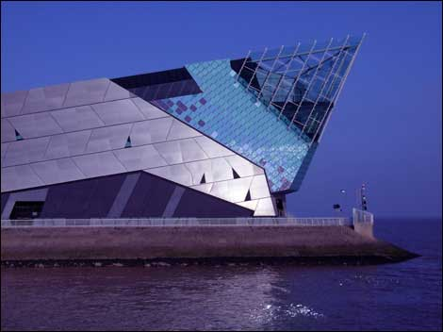
The Deep

Hull will be UK City of Culture in 2017.
After being named as one of the four finalists earlier this year, Hull’s bid attracted an outpouring of support which helped the city beat off tough competition from Dundee, Leicester and Swansea Bay.
The University of Hull has strongly supported the City of Culture team throughout the bidding process. As a ‘Hull 2017 Angel’, the University has not only pledged funding, but it is also a key contributor to the cultural value of the city. The campus will be the venue for many of the City of Culture exhibitions and events.
The year 2017 also has an added significance for the University, as it will celebrate 90 years since the institution was founded as ‘University College Hull’. The city will now deliver a spectacular programme for 2017 that will deliver artistic excellence and events on scale never seen before in the city – and will entice visitors from the whole of the UK and beyond. Inspired by Larkin’s poem ‘Days’ the ambition is for each day of Hull 2017 to make a difference to a life in the city, the UK and the world.
For further details on Hull’s UK City of Culture programme you can visit:
www.hullcc.gov.uk/2017Hull
Hull is an exciting city surrounded by the East Riding of Yorkshire. It is a fast paced riverside city that is investing in its people and its community. It is a thriving and dynamic waterfront community with a proud maritime heritage, boasting the UK’s busiest port complex. The momentum in Hull and the Humber region provides significant opportunity for existing businesses and new investors, with sites, services and expertise for UK and global operations.
The region is home to the Humber Bridge - a magnificent piece of civil engineering which took over nine years to build and is one of the world's longest single span suspension bridges - as well as The Deep, one of the most spectacular aquariums in the world and a research partner of the University of Hull.
Humber Bridge
The East Riding of Yorkshire is steeped in heritage and known for its beautiful and unspoilt countryside, open plains and rugged hills. It offers dramatic coastlines, award winning sandy beaches, picturesque villages and historic market towns. The coastal resorts of Flamborough Head, Bridlington, Hornsea and Withernsea are popular family destinations as are the Market Towns of Beverley, Howden, Driffield, Pocklington and Market Weighton for a more relaxed pace of life.
The unrivalled quality of life in Yorkshire and Humber is founded on this combination of cosmopolitan urban areas surrounded by beautiful countryside. With no less than three national parks on the doorstep of a thriving commercial landscape, this is a region where work and life really can be kept in balance. As Britain's biggest county, Yorkshire has more historic houses, castles and national parkland than anywhere else, along with the best shopping in the North.
Investment in Renewable Energy
Hull has recently attracted significant investment in renewable energy, notably from Siemens and Associated British Ports (ABP) who will be investing £310 million in creating an enormous offshore wind turbine manufacturing and installation facility across two sites in Hull and Paull in the East Riding of Yorkshire. This major investment in the UK’s offshore wind industry could create up to 1,000 jobs directly in the Humber region with many more in the supply chain, along with hundreds of jobs during the construction phase, which should commence in the Autumn of 2014. It is expected that both sites will be fully operational by mid 2017. The University of Hull, through its Centre for Adaptive Science and Sustainability (CASS), has worked with the Hull City and the East Riding of Yorkshire Councils to help bring this investment to fruition.

Getting to Hull
Hull's position at the gateway to Europe makes it an important centre for national and international travel. The city has excellent transport connections and a unique combination of air, sea, road and rail links.
By Road - Hull is equidistant (200 miles) from London and Edinburgh. The M62 joins Hull to Leeds, Manchester and Liverpool. Hull is located 100 miles from Manchester and less than an hour’s drive from Leeds and York.
By Rail - In addition to the Transpennine Express and Northern Rail, Hull has its own rail company, Hull Trains, which offers special rates to and from the city, providing seven daily direct rail services to and from London in as little as 2½ hours. Visit www.hulltrains.co.uk for more details.
By Air - Humberside International Airport is five miles south of the Humber Bridge and 30 minutes’ drive from the centre of Hull. KLM runs 4 daily flights to Amsterdam, where over 300 worldwide connections can be reached. The airport also offers year round flights to popular holiday destinations. Visit www.humberside-airport.co.uk for more details. Robin Hood Airport is one of the UK's newest Airports, an hour’s drive away, offering low cost and holiday flights to many destinations across Europe and beyond. Visit www.robinhoodairport.com for more details.
By Sea - P&O Ferries offer daily overnight services from Hull to Rotterdam and Zeebrugge. The one million passengers using the port annually can now travel on the Pride of Hull and her sister ship, Pride of Rotterdam, which are the largest cruise ferries in the world. Visit www.poferries.com for more details.

Education and Schooling
The East Riding of Yorkshire and the City of Kingston upon Hull provide a broad range of educational opportunities close to the University, including a number of Further and Higher Education Colleges (including Hull College, Bishop Burton College, East Riding College and Selby College). The East Riding of Yorkshire’s schools are performing exceptionally well, and exciting work is underway to improve the quality of education even further. The area also offers a good choice of independent schools with boarding and day school options, from nursery age to 18. Some of the leading independent schools in the area include Hymers College, Hull Collegiate School and Pocklington School. The University of Hull is also sponsoring the Thomas Ferens Academy in Hull.

Shopping, sport and culture
Hull's Museum Quarter, on the High Street in the heart of the Old Town, consists of Wilberforce House, the Arctic Corsair, the Hull and East Riding Museum (which contains the Hasholme Logboat – Britain's largest surviving prehistoric logboat), and the Streetlife Museum of Transport. Other museums and visitor attractions include the Ferens Art Gallery with a good range of art and regular exhibitions, the Maritime Museum in Victoria Square, and the Deep, a public aquarium.
The city has two main theatres. Hull New Theatre, which opened in 1939, is the largest venue which features musicals, opera, ballet, drama, children's shows and pantomime. The Hull Truck Theatre is a smaller independent theatre, established in 1971 that regularly features plays, notably those written by John Godber. Since April 2009, the Hull Truck Theatre has had a new £14.5 million, 440 seat venue in the St. Stephen’s Development. The playwright Alan Plater was brought up in Hull and was associated with Hull Truck Theatre.
Hull has produced several veteran stage and TV actors. Sir Tom Courtenay, Ian Carmichael and Maureen Lipman were born and brought up in Hull. Younger actors Reece Shearsmith, Debra Stephenson and Liam Garrigan were also born in Hull. Garrigan attended Hull's Northern Theatre Company and Wyke College.
Hull has a large number of parks and green spaces. These include East Park, Pearson Park, Pickering Park and West Park. West Park is home to Hull's KC Stadium. Pearson Park contains a lake and a 'Victorian Conservatory' housing birds and reptiles. East Park has a large boating lake and a collection of birds and animals. East Park and Pearson Park are registered Grade II listed sites by English Heritage. The city centre has the large Queen's Gardens parkland at its heart. This was originally built as formal ornamental gardens used to fill in the former Queen's Dock. It is now a more flexible grassed and landscaped area used for concerts and festivals, but retains a large ornamental flower circus and fountain at its western end.
Hull's local daily newspaper is the longstanding Hull Daily Mail, whose circulation area covers much of the East Riding of Yorkshire. The BBC has its Yorkshire and Lincolnshire regional headquarters at Queen's Gardens, from which the regional news programme Look North is broadcast.
Radio services broadcasting from the city are Hull's include BBC Radio Humberside, as well as commercial stations Viking FM, KCFM and Magic 1161, which broadcast to the wider East Riding of Yorkshire and Lincolnshire area.
Hull city centre offers a varied choice of retail department stores, a number of major shopping centres and many smaller outlets and designer boutiques set around a beautiful city park and stunning waterfront, all within easy walking distance. A number of superstores are located elsewhere in the city and surrounds.
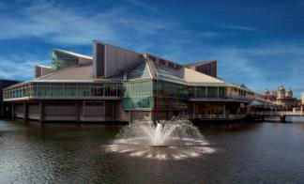
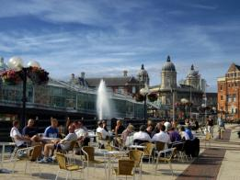
The stunning retail-led mixed-use development, St Stephens, in the city centre, has brought 50 big name brands to the city’s retail offer including Zara, H&M and Jane Norman since its opening in September 2007. As the second largest mixed-use city centre regeneration project in the UK, the state-of-the-art scheme covers a 40 acre site in the heart of Hull. The most striking feature of St Stephen's shopping and leisure complex is its dramatic, glazed canopy roof structure, which spans the length and breadth of the curved 'street', which is as wide as London's Oxford Street.
Princes Quay, a modern glass shopping centre built on stilts over the water in an old dock, is home to many of the major chain stores alongside designer outlets and is a popular choice amongst shoppers. This currently exciting offer is set to be further improved by Quay West, a major new investment which will create a dedicated retail and leisure zone as an extension of the shopping centre, providing flagship stores for retailers not yet represented in the city.
Just a few steps away from Princes Quay, shoppers can relax at the array of waterfront cafes and bars next to the Marina before following the cobbled streets to the Old Town where the indoor market offers a diverse range of goods including everything from fresh fruit and flowers to handbags and handmade cards.
The 25,000-seat Kingston Communications (KC) Stadium is home to Hull City AFC (“The Tigers”), the city’s premier league football team. “The Tigers” recently played Arsenal at the 2014 FA Cup Final at Wembley. Hull FC rugby league team is also located at the KC Stadium and Hull Kingston Rovers is located at Craven Park in East Hull.

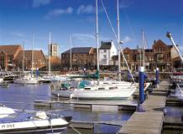
For those who prefer to participate rather than spectate, Hull offers plenty of opportunities to get the blood pumping. The region has the biggest Sunday football league in the country, and there are also top-flight rugby teams, cricket and hockey clubs as well as public and private golf and tennis clubs. Hull has the North's largest indoor full swing state-of-the-art golf simulator centre and for climbing enthusiasts, there's Rock City, one of the country's best indoor climbing centres.
The region's abundance of water makes it an excellent location for water sports, which include Fossehill, Welton Sailing Club, Yorkshire Water Ski Club and The Deep Dive School.
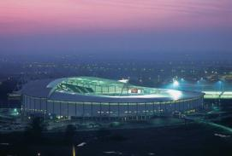
Housing
The East Riding of Yorkshire and Hull offer a diverse and impressive range of housing choices, all offering incredible value for money.
City living has burgeoned, with apartments in historic old buildings and sparkling new riverside complexes – all at a much more affordable cost than many other cities – attracting people back to the heart of the city. Georgian townhouses stand proudly in the heart of the old town. Just a stone’s throw from the city centre, leafy avenues offer more traditional housing in large Victorian properties. Many suburbs are developing a reputation for their bohemian atmosphere inviting people to enjoy the laid back lifestyle with a growth in café bars, delicatessens, boutique shops and arts venues. Waterfront city-villages offer excellent modern family housing from 1-5 bedrooms, just a short walk from work in the city centre.
Beyond the city itself, unspoilt village communities and elegant market towns in the East Riding of Yorkshire complement the urban centre. Country life still allows for easy access to the buzzing city, with secluded farmhouses available just 20 minutes from the city centre. The East Riding of Yorkshire is known for its spectacular coast and countryside, and offers a high quality of living in market towns such as Beverley, which is located only a few miles from the University of Hull.
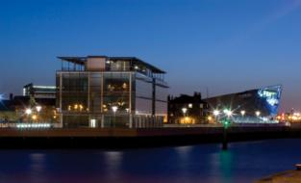
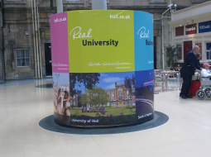
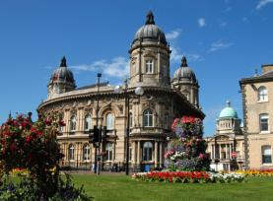

More information on Hull, the East Riding and Yorkshire
Please visit the following websites:
www.hull.co.uk www.eastriding.gov.uk
www.hullcc.gov.uk www.activhull.com
www.yorkshire.com
